2020 Men’s Outdoor Track & Field Roster

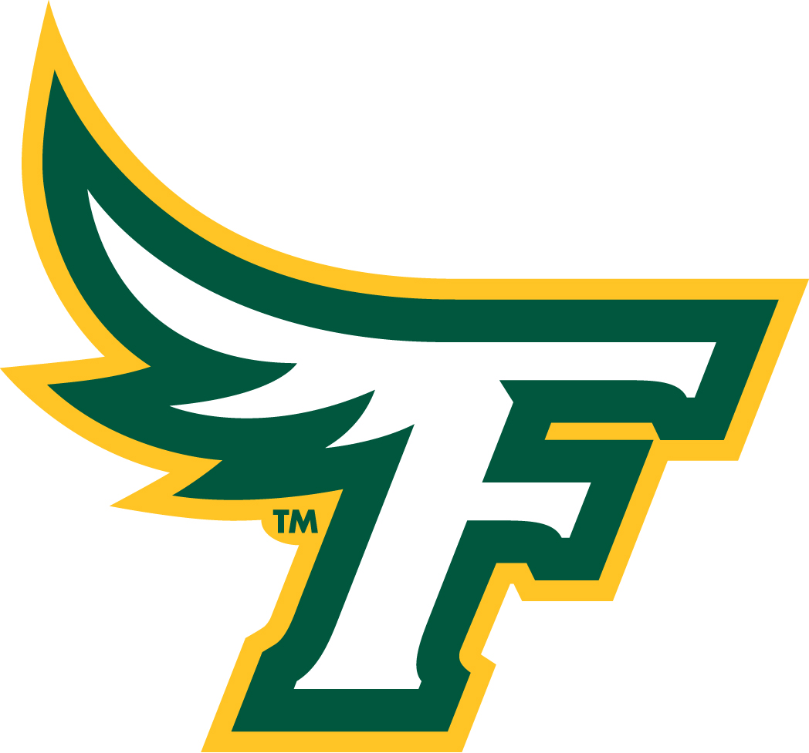
No. Name Yr. Ht. Hometown/Previous School
Joseph Asare Fr 6-0 Brockton, Mass./Brockton
Shaki Auston Fr 6-2 Springfield, Mass./Springfield Commerce
Beau Bernadeau Fr 5-11 North Andover, Mass./North Andover
Gene Bouthiette Fr 5-7 Enfield, Conn./Enfield
Zachary Buckland Sr 6-1 Billerica, Mass./Shawsheen Valley Tech
Ryan Carter Sr 5-8 Leominster, Mass./Leominster
James Casale Jr 5-6 Wakefield, Mass./Malden Catholic
Matthew Catarius Fr 5-10 Shrewsbury, Mass./St. John’s
Zanthius Collins Fr 6-1 Franklin, Mass./Franklin
Conor Dandy Fr 5-9 Westminster, Mass./Monty Tech
Cameron Davis So 5-7 Gardner, Mass./Gardner
Adam Digman Fr 6-4 Winchendon, Mass./Murdock
Romeo Fabre Fr 5-7 Leominster, Mass./Lawrence
Nathaniel Felix Fr 5-10 Worcester, Mass./Worcester Tech
Trevor Fields So 5-9 Shirley, Mass./UMass Lowe
Samuel Flint Fr 5-5 Methuen, Mass./Methuen
Andrew Hill Jr 6-4 Templeton, Mass./Mahar Regional
Sebastian Galindo Fr 5-10 Lynn, Mass./Prospect Hill Academy Charter
Tyssen LaBombard Fr 5-10 Shelburne, Mass./Greenfield
Cory Martins Fr 5-9 Three Rivers, Mass./Palmer
Michael Masterson So 5-11 Pepperell, Mass./Francis W. Parker Charter
Brandon McNeil So 6-1 Dartmouth, Mass./Darmouth
Christian McWhinnie-Armstead Jr 6-4 Lowell, Mass./Lowell
Asante Monteiro Jr 5-7 Fall River, Mass./BMC Durfee
Joel Monteiro Jr 5-10 Brockton, Mass./University of New Haven
Chris Morales Fr 5-9 Lynn, Mass./Peabody Veterans Memorial
Jacob Movsessian Jr 5-7 New Ipswich, N.H./Mascenic Regional
Brandon Patanao Fr 5-8 Marlborough, Mass./Marlborough
Ian Poyant Jr 5-9 Acton, Maine/Sanford
Shane Rafferty Fr 6-4 West Newbury, Mass./Whittier Tech
Nicholas Sachetta So 5-5 Billerica, Mass./Shawsheen Valley Tech
Benjamin Sacramone Fr 6-0 Hubbardston, Mass./Quabbin Regional
Timothy Sheehy Jr 5-10 Wakefield, Mass./South Kingstown
Eric Shimiyimana Fr 5-5 Worcester, Mass./Worcester North
Cody Soderlund So 5-6 Middleborough, Mass./Middleborough
Erick Viana Jr 5-8 Peabody, Mass./Peabody Veterans Memorial
Joe Weston Jr 5-8 Middleton, Mass./Masconomet Regional

Head Coach: Jim Jellison (42nd Season)
Assistant Coaches: Nora Lynch, Amanda Egesi, Al Halper. Kyle Wilson & Andrew St. Germaine
Captains: Christian McWhinnie-Armstead, Asante Monteiro, Jacob Movsessian, & Timothy Sheehy

2020 Women’s Outdoor Track & Field Roster

No. Name Yr. Ht. Hometown/Previous School
Allissa Carroll Jr 5-7 Boxford, Mass./Mascomomet Regional
Amy Coelho Jr 5-5 Bellingham, Mass./Bellingham
Nicole Cofer Fr 4-11 Lowell, Mass./Tewksbury
Guadalupe Dominguez Jr 5-4 Worcester, Mass./Doherty Memorial
Martha Garley So 5-3 Northbridge, Mass./Blackstone Valley Tech
Selina Gibbons So 5-2 Littleton, Mass./Littleton
Kelsie Graham So 5-7 Stoughton, Mass./Southeastern Regional
Chloe Guzman So 5-5 Pawtucket, Conn./Norwich Tech
Regan Kelly So 5-7 Wilbraham, Mass./Minnechaug Regional
Nicolette Kennedy Fr 5-4 Groveland, Mass./Essex North Shore Tech
Marissa Ladderbush Fr 5-4 Tewksbury, Mass./Tewksbury
Erin Maida Fr 5-8 Danbury, Conn./Danbury
Lilah McAndrew Fr 5-3 Old Lyme, Conn./Old Lyme
Kelly McCusker-Brown Sr 5-10 Watertown, Mass./Watertown
Samantha Moriconi Fr 5-5 Billerica, Mass./Shawsheen Valley Tech
Sydney Moulton Fr 5-6 Baldwinville, Mass./Oakmont Regional
Olivia Mullins Jr 5-1 Plaistow, NH/Timberlane
Abigail Murphy Fr 5-3 Quincy, Mass./Quincy
Sylvia Owsusu-Agyeiwaa Jr 5-3 Webster, Mass./Chelsea
Madison Podedworny Jr 5-8 Webster, Mass./Bartlett
Megan Socha Jr 5-6 Chicopee, Mass./Chicopee
Devin Tormey Fr 5-6 Fitchburg, Mass./Lunenburg
Xena Wildman-Hanlon So 4-9 Montague, Mass./Four Rivers Charter
Denise Yeboah Jr 5-7 Worcester, Mass./North
Brianna Young Sr 5-5 Mansfield, Mass./Franklin Pierce University

Head Coach: Jamie Aubuchon (Ninth Season)
Assistant Coaches: Amanda Egesi, Al Halper, Nora Lynch, Kyle Wilson and Andrew St. Germaine
Captains: Chloe Guzman, Regan Kelly, Megan Socha & Brianna Young

